Process
When you execute a program on your UNIX system, the system creates a special environment for that program. This environment contains everything needed for the system to run the program as if no other program were running on the system.
Whenever you issue a command in UNIX, it creates, or starts, a new process. When you tried out the ls command to list directory contents, you started a process. A process, in simple terms, is an instance of a running program.
The operating system tracks processes through a five digit ID number known as the pid or process ID . Each process in the system has a unique pid.
Pids eventually repeat because all the possible numbers are used up and the next pid rolls or starts over. At any one time, no two processes with the same pid exist in the system because it is the pid that UNIX uses to track each process.

Starting a Process:
When you start a process (run a command), there are two ways you can run it:
- Foreground Processes
- Background Processes

Foreground Processes:
By default, every process that you start runs in the foreground. It gets its input from the keyboard and sends its output to the screen.
You can see this happen with the ls command. If I want to list all the files in my current directory, I can use the following command:
$ls ch*.doc
This would display all the files whose name start with ch and ends with .doc:
ch01-1.doc ch010.doc ch02.doc ch03-2.doc
ch04-1.doc ch040.doc ch05.doc ch06-2.doc
ch01-2.doc ch02-1.doc
The process runs in the foreground, the output is directed to my screen, and if the ls command wants any input (which it does not), it waits for it from the keyboard.
While a program is running in foreground and taking much time, we cannot run any other commands (start any other processes) because prompt would not be available until program finishes its processing and comes out.

Background Processes:
A background process runs without being connected to your keyboard. If the background process requires any keyboard input, it waits.
The advantage of running a process in the background is that you can run other commands; you do not have to wait until it completes to start another!
The simplest way to start a background process is to add an ampersand ( &) at the end of the command.
$ls ch*.doc &
This would also display all the files whose name start with ch and ends with .doc:
ch01-1.doc ch010.doc ch02.doc ch03-2.doc
ch04-1.doc ch040.doc ch05.doc ch06-2.doc
ch01-2.doc ch02-1.doc
Here if the ls command wants any input (which it does not), it goes into a stop state until I move it into the foreground and give it the data from the keyboard.
That first line contains information about the background process - the job number and process ID. You need to know the job number to manipulate it between background and foreground.
If you press the Enter key now, you see the following:
[1] + Done ls ch*.doc &
$
The first line tells you that the ls command background process finishes successfully. The second is a prompt for another command.

Listing Running Processes:

It is easy to see your own processes by running the ps (process status) command as follows:
$ps
PID TTY TIME CMD
18358 ttyp3 00:00:00 sh
18361 ttyp3 00:01:31 abiword
18789 ttyp3 00:00:00 ps
One of the most commonly used flags for ps is the -f ( f for full) option, which provides more information as shown in the following example:
$ps -f
UID PID PPID C STIME TTY TIME CMD
amrood 6738 3662 0 10:23:03 pts/6 0:00 first_one
amrood 6739 3662 0 10:22:54 pts/6 0:00 second_one
amrood 3662 3657 0 08:10:53 pts/6 0:00 -ksh
amrood 6892 3662 4 10:51:50 pts/6 0:00 ps -f
Here is the description of all the fileds displayed by ps -f command:
Column | Description
UID | User ID that this process belongs to (the person running it).
PID | Process ID.
PPID | Parent process ID (the ID of the process that started it).
C | CPU utilization of process.
STIME | Process start time.
TTY | Terminal type associated with the process
TIME | CPU time taken by the process.
CMD | The command that started this process.
There are other options which can be used along with ps command:
Option | Description
-a | Shows information about all users
-x | Shows information about processes without terminals.
-u | Shows additional information like -f option.
-e | Display extended information.
If a process is running in background mode then first you would need to get its Job ID using pscommand and after that you can use kill command to kill the process as follows:
$ps -f
UID PID PPID C STIME TTY TIME CMD
amrood 6738 3662 0 10:23:03 pts/6 0:00 first_one
amrood 6739 3662 0 10:22:54 pts/6 0:00 second_one
amrood 3662 3657 0 08:10:53 pts/6 0:00 -ksh
amrood 6892 3662 4 10:51:50 pts/6 0:00 ps -f
$kill 6738
Terminated
Here kill command would terminate first_one process. If a process ignores a regular kill command, you can use kill -9 followed by the process ID as follows:
$kill -9 6738
Terminated

Parent and Child Processes:
Each unix process has two ID numbers assigned to it: Process ID (pid) and Parent process ID (ppid). Each user process in the system has a parent process.
Most of the commands that you run have the shell as their parent. Check ps -f example where this command listed both process ID and parent process ID.

Zombie and Orphan Processes:
Normally, when a child process is killed, the parent process is told via a SIGCHLD signal. Then the parent can do some other task or restart a new child as needed. However, sometimes the parent process is killed before its child is killed. In this case, the "parent of all processes," init process, becomes the new PPID (parent process ID). Sometime these processes are called orphan process.
When a process is killed, a ps listing may still show the process with a Z state. This is a zombie, or defunct, process. The process is dead and not being used. These processes are different from orphan processes.They are the processes that has completed execution but still has an entry in the process table.

Daemon Processes:
Daemons are system-related background processes that often run with the permissions of root and services requests from other processes.
A daemon process has no controlling terminal. It cannot open /dev/tty. If you do a "ps -ef" and look at the tty field, all daemons will have a ? for the tty.
More clearly, a daemon is just a process that runs in the background, usually waiting for something to happen that it is capable of working with, like a printer daemon is waiting for print commands.
If you have a program which needs to do long processing then its worth to make it a daemon and run it in background.

The top Command:
The top command is a very useful tool for quickly showing processes sorted by various criteria.
It is an interactive diagnostic tool that updates frequently and shows information about physical and virtual memory, CPU usage, load averages, and your busy processes.
Here is simple syntax to run top command and to see the statistics of CPU utilization by different processes:
$top

Job ID Versus Process ID:
Background and suspended processes are usually manipulated via job number (job ID). This number is different from the process ID and is used because it is shorter.
In addition, a job can consist of multiple processes running in series or at the same time, in parallel, so using the job ID is easier than tracking the individual processes.
Job control

A job is a group a processes .Normally when we use the pipeline facility and connect two or more commands system creates a job for it .user can
1. Send the job background
bg command send the job background
e.g $ bg
Here current foreground job send to background .

2. Bring the job in foreground .
fg command bring the job foreground
e.g $ fg
Here last background job comes in foreground
3. List the active job
4. Suspend the foreground job
5.kill job

Kill command
Some of the situation in which a user want to terminate a process in the middle of its execution are as follow:

- If the terminal is hang up.
- A user program is running in infinite loop and hence is not terminated.
- The system performance degrades because of many processes running in the background.so that a user wants to terminate a few time consuming processes.
To overcome these situation you would like to kill/terminate the process.the general syntax of kill command is as follow.

kill PID

The kill command is usually kill the process which is currently executed .
e.g. kill PID
kill 120
kill $$
kill $!
$$ stores the PID of shell and $! Stores the PID of last executed command. If we kill the parent process , all child processes are kill automatically .

User must know the PID of process which he wants to kill the process. Normally kill sends the signal to kill the process . It is signal no.15. It is default signal so user doesn’t need to pass it. Sometimes kernel ignore the signal and don’t kill the process at that time kill provides the signal no.9 to surely kill the process.
e.g kill -9 $$

nohup command

Every command in Linux starts a process at the time of its execution, which automatically gets terminated upon exiting the terminal. Suppose, you are executing programs over SSH and if the connection drops, the session will be terminated, all the executed processes will stop, and you may face a huge accidental crisis. In such cases, running commands in the background can be very helpful to the user and this is where nohup command comes into the picture. nohup (No Hang Up) is a command in Linux systems that runs the process even after logging out from the shell/terminal.
Usually, every process in Linux systems is sent a SIGHUP (Signal Hang UP) which is responsible for terminating the process after closing/exiting the terminal. Nohup command prevents the process from receiving this signal upon closing or exiting the terminal/shell. Once a job is started or executed using the nohup command, stdin will not be available to the user and nohup.out file is used as the default file for stdout and stderr. If the output of the nohup command is redirected to some other file, nohup.out file is not generated.
Syntax:
nohup pid &
nohup 302 &

Nice and Renice Command

Nice command in unix helps in execution of a program/process with modified scheduling priority. It launches a process with a user-defined scheduling priority. In this, if we give a process a higher priority, then Kernel will allocate more CPU time to that process. Whereas the renice command allows you to change and modify the scheduling priority of an already running process. Linux Kernel schedules the process and allocates CPU time accordingly for each of them.
There are a total of 140 priorities and two distinct priority ranges implemented in Linux. The first one is a nice value (niceness) which ranges from -20 (highest priority value) to 19 (lowest priority value) and the default is 0,

Working with nice and renice Command
1. To check the nice value of a process.
ps -l | grep terminal

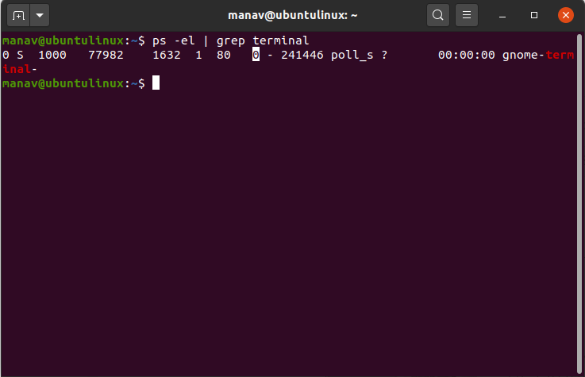
The eight highlighted value is the nice value of the process.

2. To set the priority of a process

nice -10 gnome-terminal
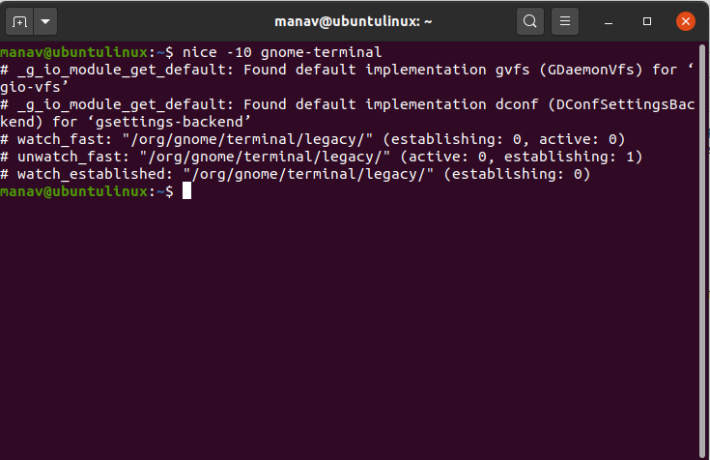
This will set the nice value of the mentioned process.

3. To set the negative priority for a process
nice --10 gnome-terminal

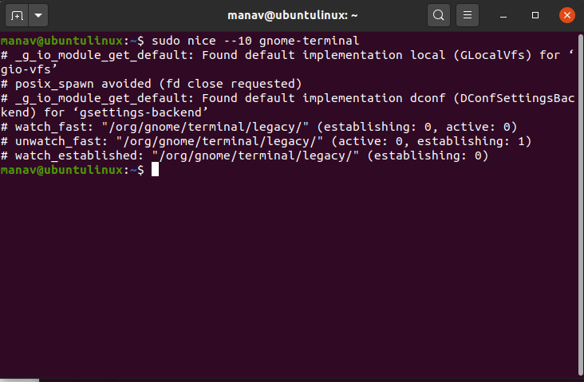
This will set the negative priority for the process.
4.changing priority of the running process.
renice -n 15 -p 77982

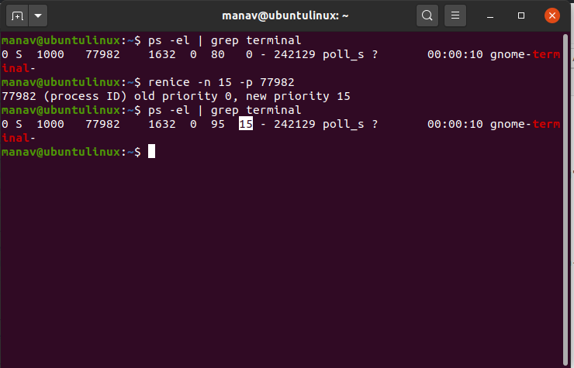
This will change the priority of the process with pid 77982.
5. To change the priority of all programs of a specific group.

renice -n 10 -g 4

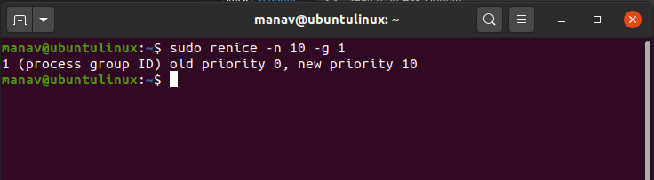
This command will set all the processes of gid 4 priority to 10.
6. To change the priority of all programs of a specific user.
sudo renice -n 10 -u 2

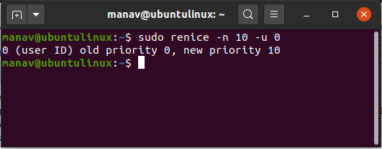
This will set all the processes of user 2 to 10.

Atcommand
At command is a command-line utility that is used to schedule a command to be executed at a particular time in the future. Jobs created with at command are executed only once. The at command can be used to execute any program or mail at any time in the future. It executes commands at a particular time and accepts times of the form HH:MM to run a job at a specific time of day. The following expression like noon, midnight, teatime, tomorrow, next week, next Monday, etc. could be used with at command to schedule a job.
Working with at command
1. Command to list the user’s pending jobs:
at -l
or
atq
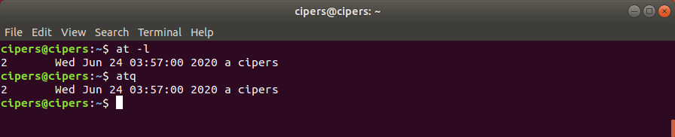
2. Schedule a job for the coming Monday at a time twenty minutes later than the current time:
at Monday +20 minutes
3. Schedule a job to run at 1:45 Aug 12 2020:
at 1:45 081220
4. Schedule a job to run at 3pm four days from now:
at 3pm + 4 days
5. Schedule a job to shutdown the system at 4:30 today:
# echo "shutdown -h now" | at -m 4:30
6. Schedule a job to run five hour from now:
at now +5 hours
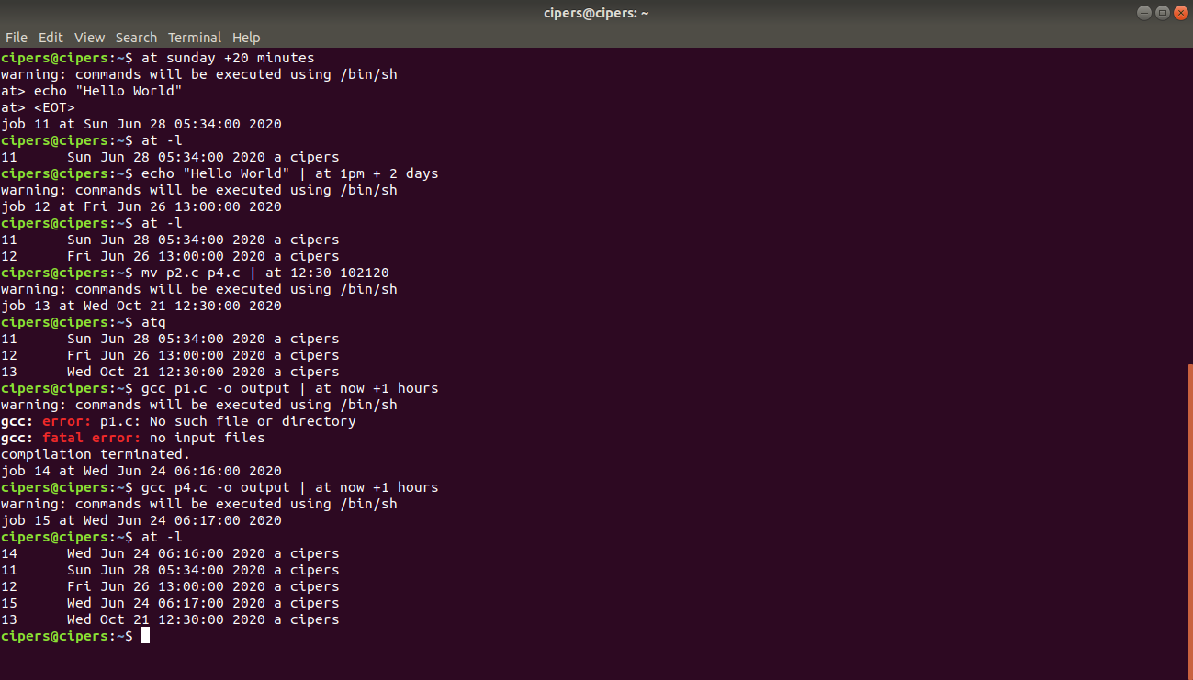
7. at -r or atrm command is used to deletes job , here used to deletes job 11 .
at -r 11
or
atrm 11
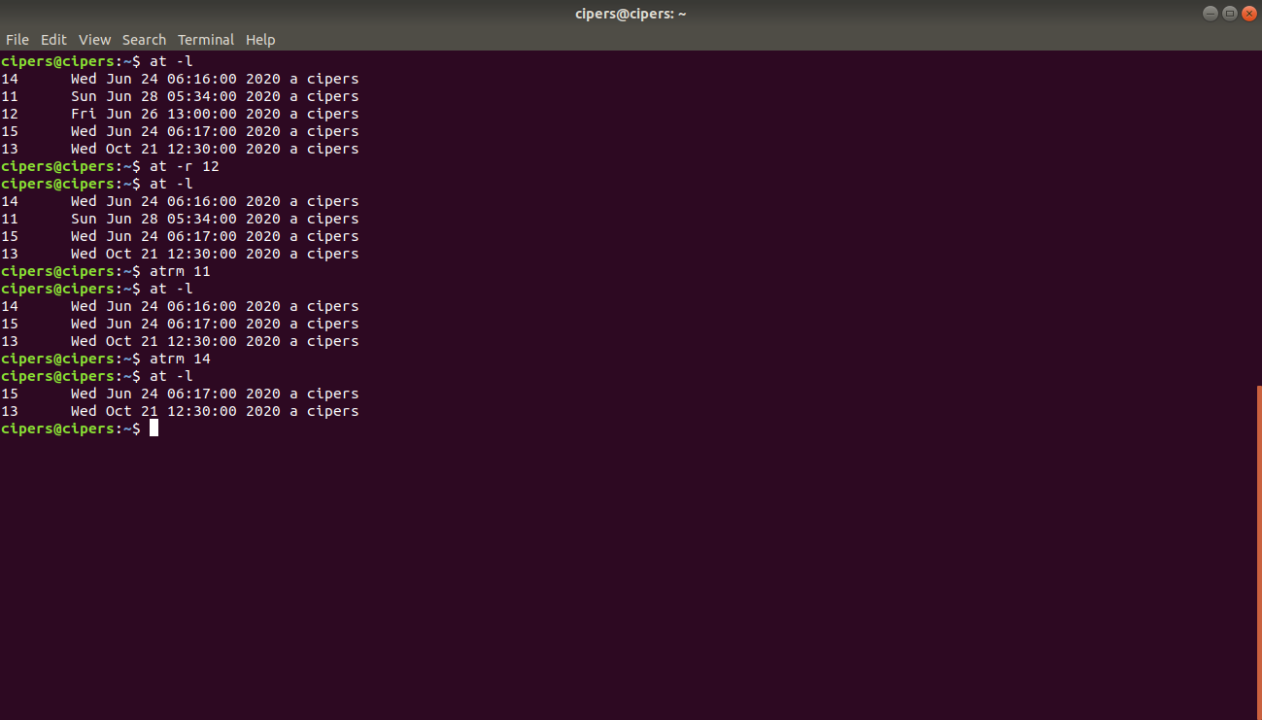

Batch command

It allow unix to execute your job as and when the system load light.the batch command is useful for running a process or shell program that uses a large amount of system time .the general form of this command is as follow:
Batch[option]
This command does not accept any time from the user,since it is left to the system to decide when to execute the job.

You can invoke batch command as follow:
$batch
sort myfile > sortfile
Ctrl –d
Job 855 at 2020-03-26 13:57
It submit job in a queue and runs immediately when system load is light.
Any job scheduled with batch command also goes to at queue.therefore to display all the jobs submitted by batch will be display using at –l and also be removed with the command at –r job number(in linux atrm job number)

